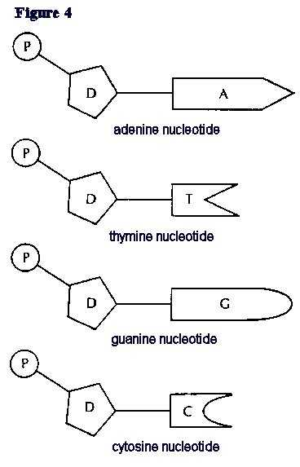

DNA Bases
DNA is made up of a twisted double strand (double helix) of special chemicals called nitrogen bases. The sequence these bases come in stores genetic information, like an alphabet with only 4 letters.
Instructions.
- Colour all of the adenines (A) red.
- Colour all of the thymines (T) blue.
- Colour all of the cytosines (C) green.
- Colour all of the guanines (G)orange.
- Cut out JUST THE FIRST 4 nucleotides.
- Match the bases to second set of nucleotides.
- Glue them in place.

A= _____________ and always joins to _____________( ) bases.
T = _____________ and always joins to _____________( ) bases.
C = _____________ and always joins to _____________( ) bases.
G = _____________ and always joins to _____________( ) bases.
This is called __________________ base pairing.
Which molecule is the base always joined to?________________
What does P stand for? _____________________
The base, sugar and phosphate joined together is called a _______________.

